Time: 60 minutes
Directions: Each of the 30 multiple-choice questions is followed by five possible answer choices. Choices A through D will provide answers, while Choice E is for none of the above. Scoring will be as follows: 5 points for a correct answer, 0 for a wrong answer, and 1 for a blank answer (for a maximum possible score of 150). Figures are not necessarily drawn to scale. Do not choose incomplete answers: if a question has more than one solution, do not select a choice that only provides one of the solutions! Calculators are not permitted.

1. Willy Wonka has exactly three and a half boxes of peppermint sticks and two and
one-third boxes of chocolate bars. If there are 20 peppermint sticks per box, and 18 chocolate bars per box, how many pieces of candy does he have?
A) 96 B) 104 C) 112 D) 116 E) NOTA

2.
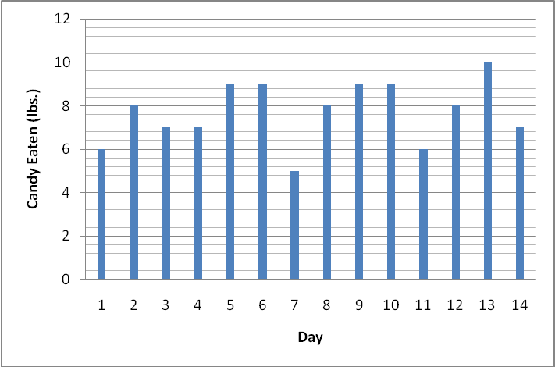

Augustus made a graph showing the pounds of candy he ate per day over a 2 week period. What is the average amount of candy he ate per day, in pounds?
A) 6.5 B) 7.7 C) 8.7 D) 10 E) NOTA

3. Veruca Salt whined for 36 straight hours! How many minutes did she whine for?
A) 36 B) 2160 C) 3600 D) 129,600 E) NOTA

4. Charlie’s family is very poor and lives on only $2.50 a day. They spend $1.75 a day on food. What percentage of their daily spending is used on food?
A) 0.7 B) 1.43 C) 60 D) 70 E) NOTA

5 After being teleported through Willy Wonka’s Television Chocolate Machine, Mike Teavee shrunk till he was only one-thirteenth of his original size! If Mike was originally 52 in. tall, how fall is he after being teleported?
A) 3 in. B) 4 in. C) 3 ft. D) 4 ft. E) NOTA

6. Willy Wonka has x number of buttons in his glass elevator. If 3x-1050+49=2449, how many buttons are in his glass elevator?

A) 1050 B) 1150 C) 1200 D) 1250 E) NOTA

7. Oompa-Loompa #1 is two years older than half the age of Oompa-Loompa #2. Oompa-Loompa #2 is two-thirds the age of Oompa-Loompa #3. If Oompa-Loompa #3 is 30 years old, what is the combined age of Oompa-Loompa #1 and Oompa-Loompa #2?
A) 32 B) 33 C) 40 D) 41 E) NOTA

8. Mike Teavee loves to watch T.V. He watches no less than t hours of T.V. a week and no more than v hours of T.V. a week. If 10t + 10 = 110 and 6v + 10 = 100, what is one possibility for the number of hours Mike watched T.V. this week?
A) 6 B) 12 C) 16 D) 20 E) NOTA

9. Willy Wonka’s nut-cracking squirrels are arranged in a circle that has a diameter of 42 ft. What is the area of this circle in yards?
A) 49 yd.² B) 196 yd.² C) 441 yd.² D) 1764 yd.² E) NOTA

10. Willy Wonka’s chocolate waterfall dumps [(6+12÷2) + (2)(2)]
[2+1•2]
gallons of water into the chocolate river per second. How many gallons of chocolate is dumped per second?
- 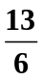 B) 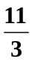 C) 4 D) 5 E) NOTA
10
11.
8

20
Willy Wonka has a room covered in edible grass with the dimensions shown in the diagram above. What is the area of this room?
A) 80 B) 160 C) 200 D) 240 E) NOTA

12. Willy Wonka has called 7 Oompa-Loompas, including the chief, to stand in a line. If the chief has to be in the middle of the line, how many ways can the remaining 6 Oompa-Loompas be arranged in a line?
A) 6 B) 36 C) 720 D) 5040 E) NOTA

13. Augustus Gloop eats too much candy! He ate 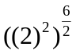 pounds of candy today. How many pounds of candy did he eat today?
A) 4 B) 8 C) 32 D) 64 E) NOTA

14. There are 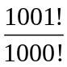 rooms in Willy Wonka’s factory. Given that 5!= (5)(4)(3)(1)(1), how many rooms are in his factory?
A) 1 B) 101 C) 1001 D) 100,010,000 E) NOTA

15. All five of the Golden Ticket holders are standing in a line. Veruca stands behind Charlie but in front of Mike. Mike is in front of Violet. Augustus is directly behind Charlie. Who is second in line?
A) Augustus B) Charlie C) Mike D) Veruca E) NOTA

16. Which of the following is the sum of two distinct prime numbers?
A) 2 B) 3 C) 4 D) 5 E) NOTA

17. 3^{C} + 3^{A} + 3^{N} + 4^{D} + 4^{Y} =
A) 3(CAN) + 4(DY) B) 3^{CAN} + 4^{DY} C) 3^{(C+A+N)} + 4^{(D+Y})
D) 17^{CANDY} E) NOTA

18. Willy Wonka has chocolate syrup stored in a trapezoidal prism container. The trapezoidal base has a height of 2 ft. and a set of parallel lines with lengths of 2 ft. and 4 ft. The prism has a height of 11 ft. What is the volume of the conatiner?
A) 66 ft.² B) 132 ft.² C) 66 ft.³ D) 132 ft.³ E) NOTA

19. 10c >20
3b ≤ 0
Which of the following cannot be the value of cb?
- -5 B) -2 C) 0 D)2 E) NOTA

20. If (3^{x})⁴ = 3⁵², what is the value of x?
A) 4 B) 13 C) 18 D) 48 E) NOTA

21. If y² = 225, what is y⁰?

- -15 B) 0 C) 1 D) 15 E) NOTA

22. What is the GCF of 15x⁴y⁶, 30x²y³, and 45x⁹y¹⁰?
A) 5 B) 5x⁴y⁶ C) 15 D) 15x²y³ E) NOTA

23. Simplify 3 wo³n²k⁵a • 4 w²o³nka
3 6 w²o³nk²a³

A) 2w³o³nk⁵a B) 2w³o³k⁵a C) w³o³n²k⁵ D) 2w³o³n²k⁵ E) NOTA
3 3n 6a 3a

24. Violet Beauregard has been chewing the same piece of gum for g days!
If 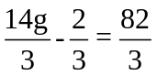, how many days has she been chewing this piece of gum?
A) 6 B) 7 C) 8 D) 9 E) NOTA

25. Greedy Augustus Gloop falls into the chocolate river and gets sucked into a tube! But since Augustus is too fat, he takes 240% more time than the average kid to travel through the tube. If the average kid takes 15 seconds to travel through the tube, how many seconds does it take Augustus to travel through the tube?
A) 36 B) 51 C) 56 D) 3600 E) NOTA

26. Charlie Bucket’s family can only afford 252 oz. of cabbage per week. If the Bucket family wants to have the same portion of cabbage each meal, and they eat three meals per day, how many pounds of cabbage can the family have per meal?
A) 0.5 lb B) 0.75 lb. C) 1 lb. D) 1.5 lb. E) NOTA

27. If a ☺ b = a² + b³, then 3 ☺ 4 =
A) 18 B) 43 C) 73 D) 16807 E)NOTA

28. Willy Wonka has 20.85 lbs. of licorice. If he wants to put the licorice into bags that can hold 5 lbs., how many bags will he need to put away all the licorice?
A) 3 B) 4 C) 5 D) 6 E) NOTA

29. Simplify: 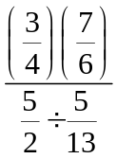
A) 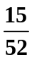 B) 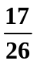 C) 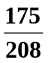 D) 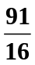 E) NOTA

30. Solve for x: 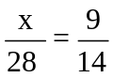
A) 7 B) 8 C) 9 D) 18 E) NOTA

